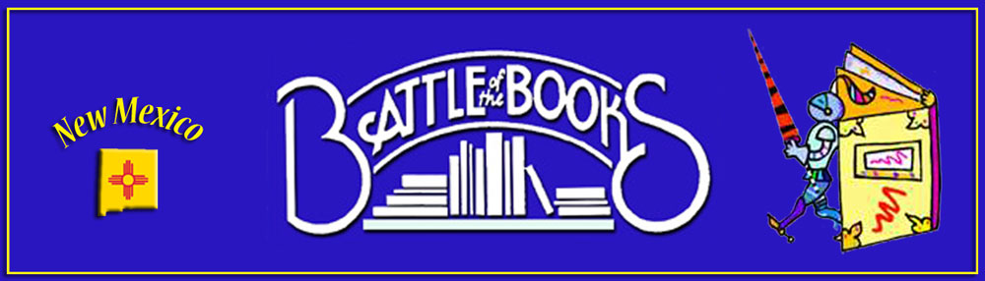

New Mexico Battle of the Books
2017-2018 Middle School Level List

The Girl Who Drank the Moon by Kelly Barnhill

Nine, Ten: A September 11 Story by Nora Raleigh Baskin

The Mighty Miss Malone by Christopher Paul Curtis

What Elephants Know by Dinerstein, Eric

Garvey's Choice by Grimes, Nikki

I Am Drums by Mike Grosso

The Forgetting Machine by Pete Hautman

Sunny Side Up by Jennifer L. Holm and Matthew Holm

The Boys Who Challenged Hitler by Phillip Hoose

No More Dead Dogs by Gordan Korman

A Handful of Stars by Cynthia Lord

Fast Break by Mike Lupica,

Where the Broken Heart Still Beats by Carolyn Meyer

A Night Divided by Jennifer Nielsen

Pax by Sara Pennypacker

Story Thieves by James Riley

Some Writer by Melissa Sweet

Heir Apparent by Vivian Vande Velde

My Guardian Angel by Sylvie Weil

Someone Named Eva by Joan M. Wolf

